# Redefining a View in SQL

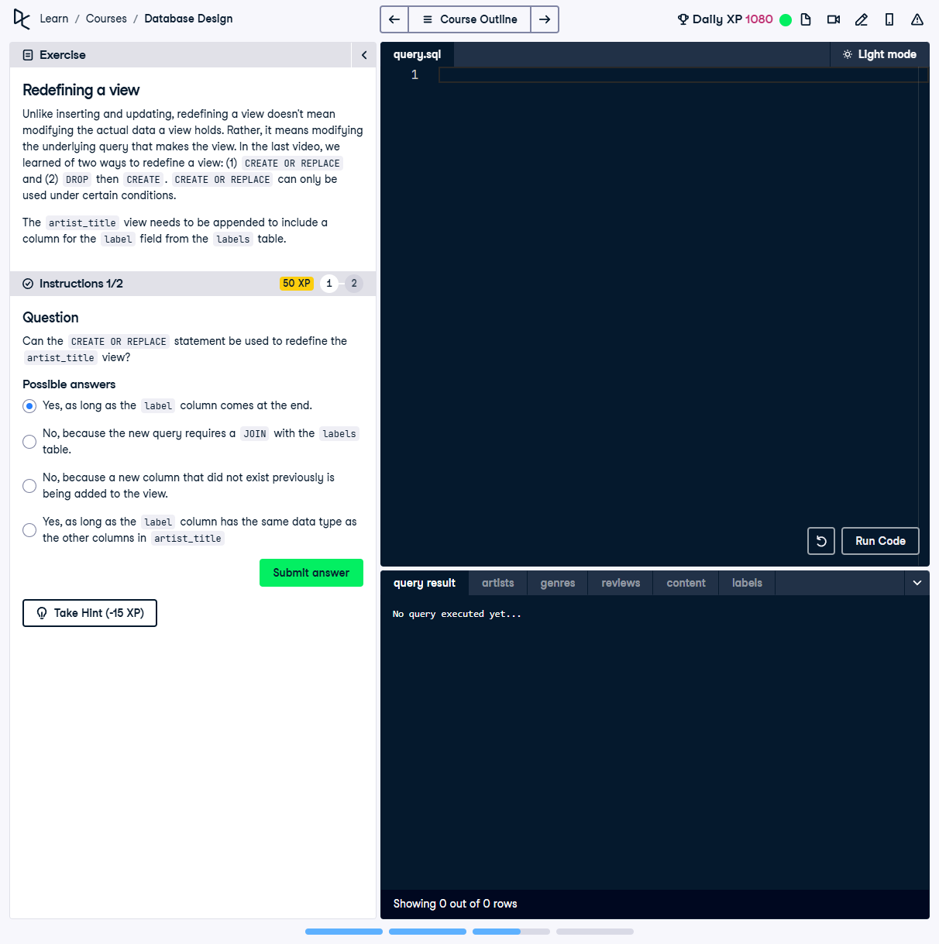

## Question:

Can the `CREATE OR REPLACE` statement be used to redefine the `artist_title` view?

## Possible Answers:

1. Yes, as long as the `label` column comes at the end.

2. No, because the new query requires a `JOIN` with the `labels` table.

3. No, because a new column that did not exist previously is being added to the view.

4. Yes, as long as the `label` column has the same data type as the other columns in `artist_title`.

## Correct Answer:

Yes, as long as the `label` column comes at the end.

## Explanation of the Answer:

The correct answer is `Yes, as long as the label column comes at the end.` `CREATE OR REPLACE` can modify an existing view, but it must retain the same column order for existing columns. Adding a new column is allowed as long as it is appended at the end of the column list.